EXPERIMENT NO. 15
WORKING WITH GIT BRANCHES AND RESOLVING MERGE
CONFLICTS
AIM
To work with Git branches while collaborating, merge the main branch into a feature branch,
resolve merge conflicts manually, and push the result to GitHub with a pull request.
SOFTWARE / TOOLS REQUIRED
- Git (Git Bash)
- GitHub
- Visual Studio Code
PROCEDURE
Step 1: Clone the Shared Repository
- Open Git Bash or the terminal on the local machine.
- Copy the HTTPS URL of the shared GitHub repository.
- Clone the repository using the following command:
git clone &lt;repository_url&gt;
- Navigate into the cloned repository:
cd &lt;repository_name&gt;
- Verify the repository files using:
Ls
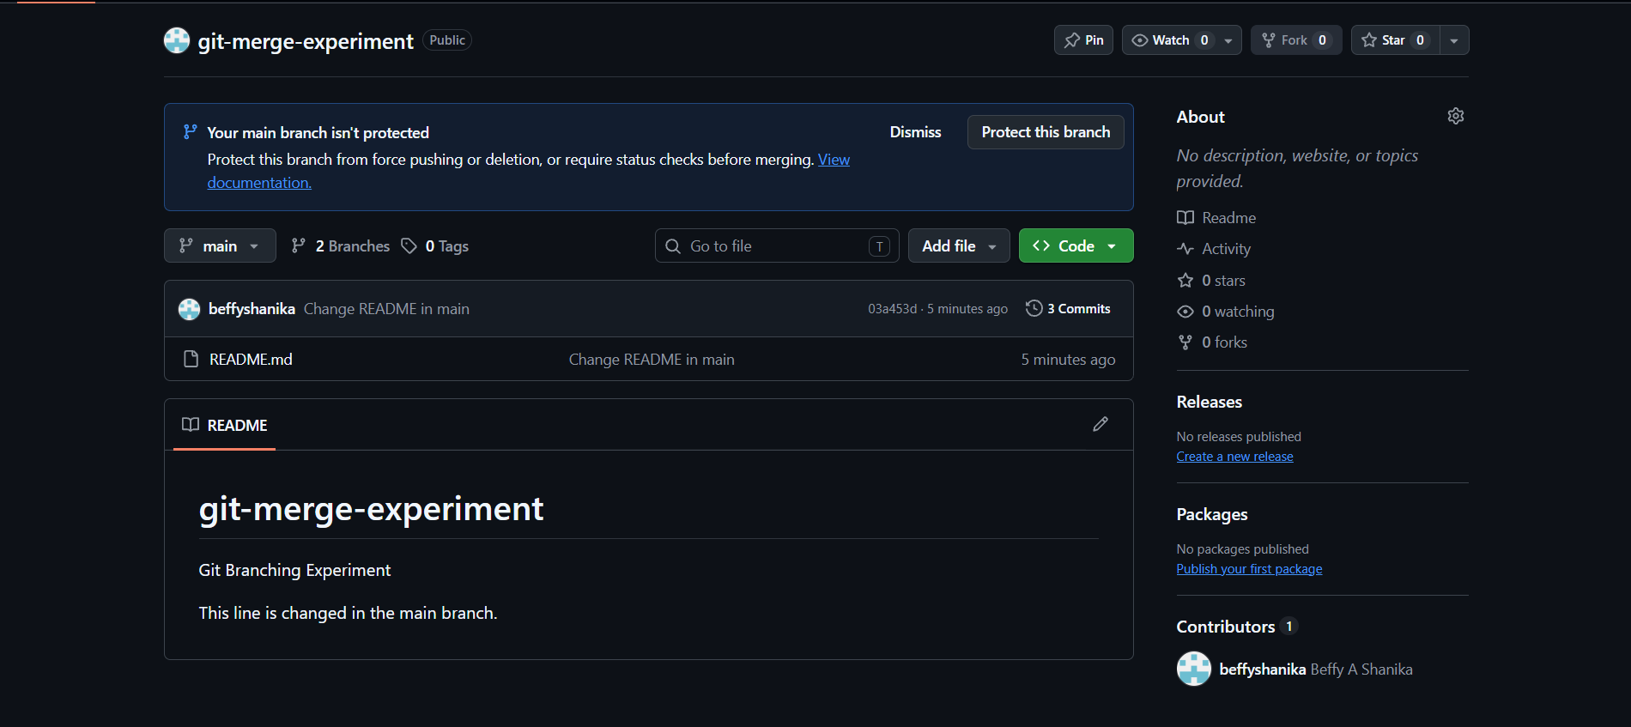
Step 2: Create and Switch to a New Branch
- Create a new feature branch using:
git checkout -b feature-update
- Verify the current branch:
git branch
Step 3: Make Changes to a File
- Open the repository in Visual Studio Code:
code .
- Open a file such as README.md.
- Add or modify a small section of content.
- Save the file using Ctrl + S.
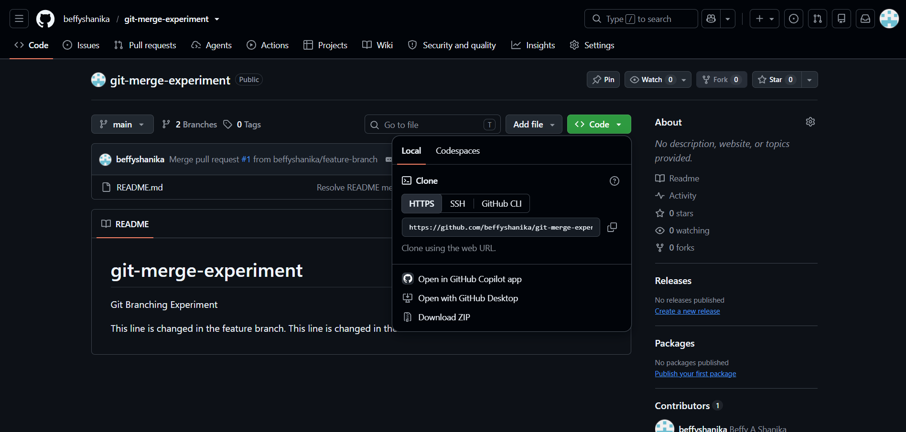
Step 4: Check and Commit the Changes
- Check the modified files:
git status
- Stage the modified file:
git add README.md
- Commit the changes:
git commit -m &quot;Updated README&quot;
Step 5: Push the Feature Branch
- Push the feature branch to GitHub:
git push -u origin feature-update
- Verify that the feature branch has been successfully pushed to the remote repository.
Step 6: Switch to the Main Branch
- Switch from the feature branch to the main branch:
git checkout main
- Verify the current branch:
git branch
Step 7: Pull the Latest Changes from the Main Branch
- Get the latest changes from GitHub:
git pull origin main
- Wait for the pull operation to complete successfully.
Step 8: Switch Back to the Feature Branch
- Switch back to the feature branch:
git checkout feature-update
- Verify the current branch:
git branch
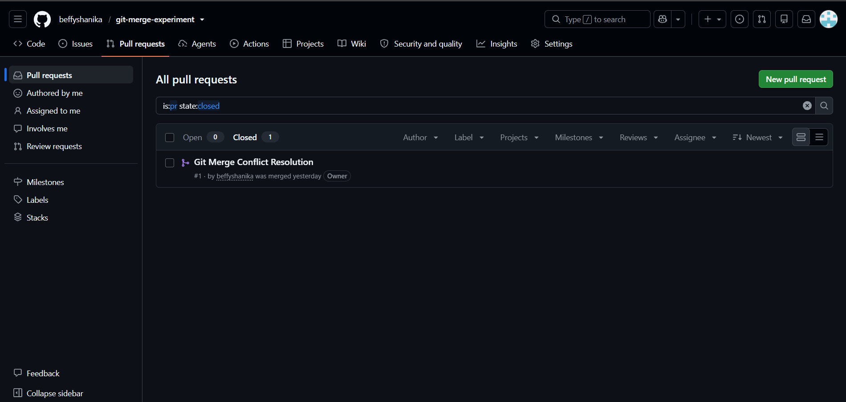
Step 9: Merge the Main Branch into the Feature Branch
- Merge the latest main branch changes into the feature branch:
git merge main
- If there are no conflicts, the merge will complete automatically.
- If a conflict occurs, Git will display the conflicting files.
Step 10: Resolve the Merge Conflict
- Open the conflicting file in Visual Studio Code.
- Locate the conflict markers:
&lt;&lt;&lt;&lt;&lt;&lt;&lt; HEAD
Your feature branch changes
Changes from main branch
&gt;&gt;&gt;&gt;&gt;&gt;&gt; main
- Decide which changes should be kept or combine both changes.
- Remove the conflict markers:
&lt;&lt;&lt;&lt;&lt;&lt;&lt; HEAD
&gt;&gt;&gt;&gt;&gt;&gt;&gt; main
- Save the file.
- Check the conflict status:
git status
Step 11: Mark the Conflict as Resolved and Commit
- Stage the resolved file:
git add &lt;conflicted_file&gt;
- Commit the resolved merge:
git commit -m &quot;Resolved merge conflict&quot;
- Verify that the working tree is clean:
git status
Step 12: Push the Merged Feature Branch
- Push the updated feature branch to GitHub:
git push origin feature-update
- Open the GitHub repository.
- Create a Pull Request from feature-update to main.
- Enter a suitable title and description.
- Click Create pull request.
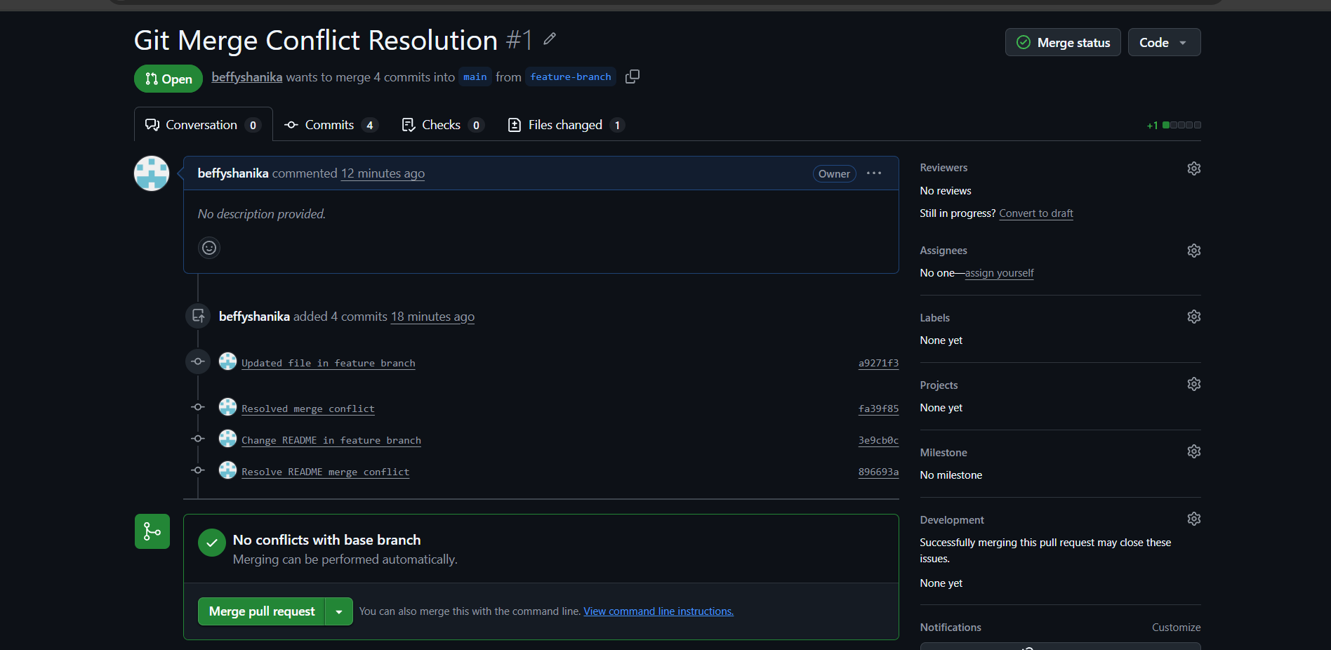
Step 13: Verify the Pull Request
- Open the created Pull Request on GitHub.
- Verify that the feature branch contains the merged changes.
- Check the Files changed section to verify the final changes.
EXPECTED OUTPUT
- Feature branch feature-update created and pushed.
- Merging main into feature-update shows CONFLICT (content): Merge conflict in README.md.
- Conflict resolved, committed as “Resolved merge conflict”, pushed, and a pull request created from feature-update to main.
RESULT
Thus Git branches were used for collaboration, the merge conflict between the feature and main branches was resolved manually, and the merged feature branch was pushed with a pull request.

